- INTRODUCTION TO INTERNET BANKING

Internet Banking allows customers to conduct financial transactions on a secure web Site Operated by their virtual Bank, Credit Union. In addition to performing Banking Transactions, Monitoring Bank Balances, Managing finances.
Support of Multiple users having varying levels of authority. It can be accessed any time from anywhere giving you complete control over finances.
Internet trading is referred to as a wide variety of systems that provide electronic order routing, automated trade execution, and electronic dissemination of pre-trade and post-trade information. With the help of the Internet trading systems, the transactions can be executed at a remote server and information can be conveyed to a remote location. And Internet Banking means the provision of retail and small value banking products and services through electronic channels and large value electronic payments and banking services are provided.

2. SYSTEM ANALYSIS & REQUIREMENTS
2.1 REQUIREMENTS
2.1.1 SOFTWARE REQUIREMENTS

Operating System : Windows XP
Programming Language : Java
Back-End : oracle-9i
Editor : Rational Rose Software (IBM EDITION 2003)
Browser used : Internal Explorer
Documentation : Microsoft Word
Web server : J2EE, XML, WEB2.0.
Modeling Language : UML

2.1.2 HARDWARE REQUIREMENTS

Processor : Pentium processor
Memory : 128MB RAM
Hard Disk : 7GB
Display : Super VGA (800*600)
Processor speed : 2.0 G .B

2.1.3 FUNCTIONAL REQUIREMENTS

- END-USER: This denotes the account holder having no. of accounts in various banks.
- ADMIN: This actor denotes the admin who maintains and updates the database of accounts and transactions.
- WEB PAGE: This opening page of the application.
- LOGIN: This login indicates that the user has to login with his id and password to view his list of accounts and perform various transactions and the admin validates the id and password.
- VALIDATION: This is performed by the administrator for password verification of end-user.
- SELECT ACCOUNT FORM LIST: The end-user selects an account from the list of accounts he had and views his balance details in the particular account.
- DISPLAY BALANCE: This attribute is used to display the balance in the selected account.
- MINI STATEMENT: This is used to know the last 10 transaction detail of end-users account.
- FUNDS TRANSFER: This is used to transfer money from one account to another account.
- REQUEST FOR CHEQUE BOOK/CHANGE OF ADDRESS: This is used by the end-user to request the admin for his cheque book and change of address.
- ANNUAL STATEMENTS: This is used to retrieve yearly transactions by the end-user.
- TRANSFER: Transfers the money from the end-users account to the destination account no.
- REQUEST FOR THE CHEQUE BOOK: The end-user requests for the cheque book.

- REQUEST FOR THE CHANGE OF ADDRESS: The end-user requests the admin for the change of address.
- ENTER CURRENT DETAILS: The end-user enters the current address.
- MODIFIERS: The admin modifies the address of the end-user with the current address.

2.2 ANALYSIS

Analysis focuses on producing a model of the system, called the analysis model, which is correct, complete, consistent, and verifiable.
Analysis model is composed of three individual models
- Functional model
- Analysis object model
- Dynamic model
The functional model is represented with use case diagrams, the object model with class diagrams, and the dynamic model with state chart and sequence diagrams.
The analysis object model consists of entity, boundary and control objects. Entity objects represent the persistent information tracked by the system. Boundary objects represent the interactions between the actors and the system. Control objects are in charge of realizing use cases.
Generalization is the modeling activity that identifies abstract concepts from lower-level ones. Specialization is the activity that identifies more specific concepts form a high-level one.

2.2.1 USE CASE DIAGRAM

It is used to indicate the existence of use case actors and their relationship and the courses of action that can be performed. The purpose of diagram is to present a kind of content diagram by which one can quickly understand the actors of a system and best ways in which they can be used.
Notation of Use case and actor
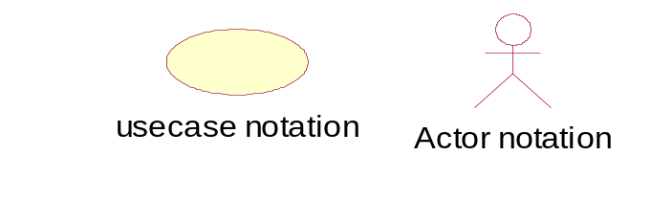
Who is an Actor?
- An actor may be a person or an external system or an organization who interacts with our system.
- An actor is one who provides information to the system or else receive information from the system.
What is a Use case?
- A use case represents a goal that an actor wants to achieve by interacting with our system.
- For example take ATM as example the task of withdrawing money can be represented by a single use case.

Relationships in Use Case Diagram
- Communication: Connecting the actor symbol to the use case symbol with a solid path shows the communication relationship of an actor in a use case. The actor is said to communicate with the use case.
- Uses: It occurs when the use cases have some sub flow; the system can have common sub flow and make it a use case of its own.
- Include: A use case continues description of behavior, by including another use case. Relieves repetition of tedious description.
- Extend: It is used when the system has a sub use case, which has specialized features. Example: exceptions.

web page
select account
from list
display balance
<<include>>
mini statement
funds transfer
request for cheque
book/ change of address
annual statement
exit
opens
end user
validation
admin
registration
login
<<include>>
<<uses>>
maintains
Fig 2.2.1.1: use case diagram for all the actors involved in the banking system

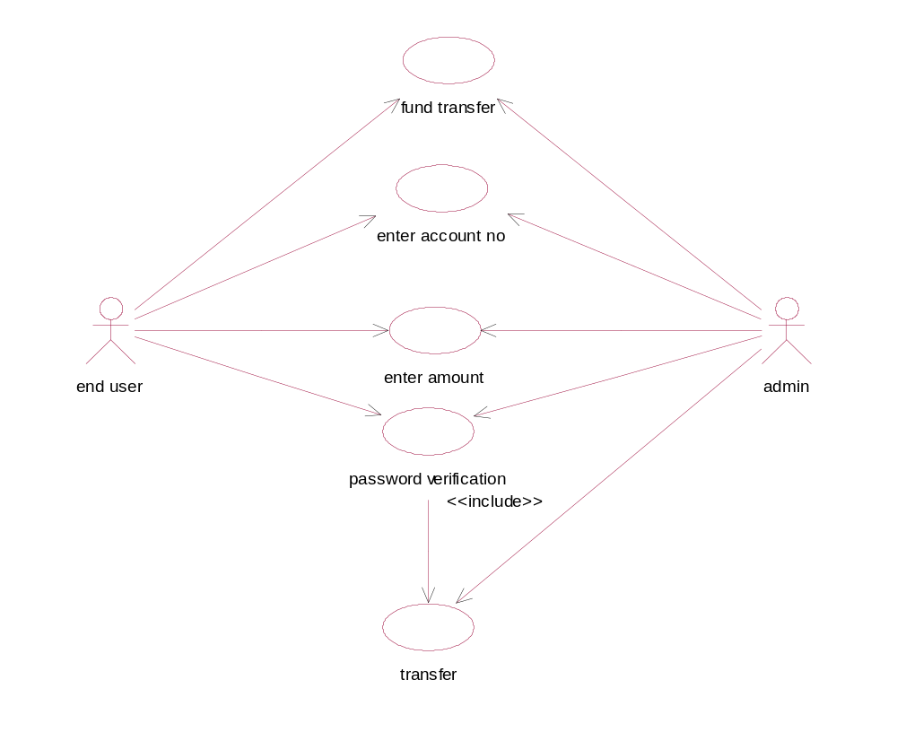

Fig.2.2.1.2 Use case Diagram for fund transfer attribute

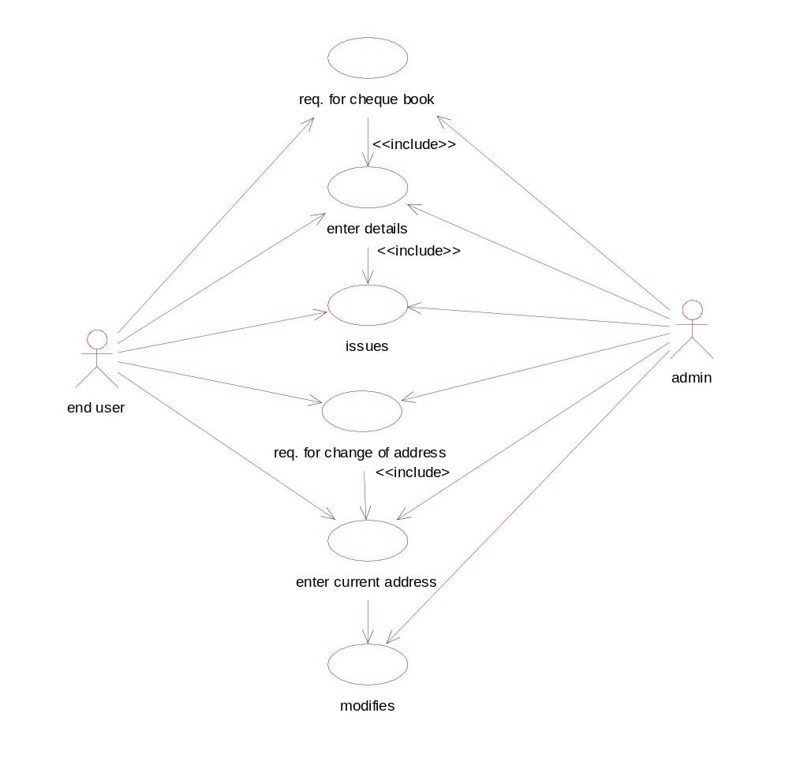
Fig 2.2.1.3 Use Case Diagram for request attribute

2.2.2 SEQUENCE DIAGRAM

It displays interaction between objects that focus on the message from temporal stand point. The sequence diagram representation focuses on expressing interaction. An object is represented by a rectangle and its life line is represented by a vertical bar and dashed line.

Sequence diagram show interaction between objects in a system and also specify the sequence in which those interactions happen and add the dimension of time to your diagram
.
In sequence diagram we only talk about time and ordering but not about the duration of time. In sequence diagrams objects are sometimes referred to as participants. We say that objects communicate in a sequence diagram but this doesn’t mean in strict sense that these objects should be instances of the class. Objects in the sequence diagrams interact by sending messages to each other.

Types of messages
- Synchronous messages
- Asynchronous messages
- Message to Itself

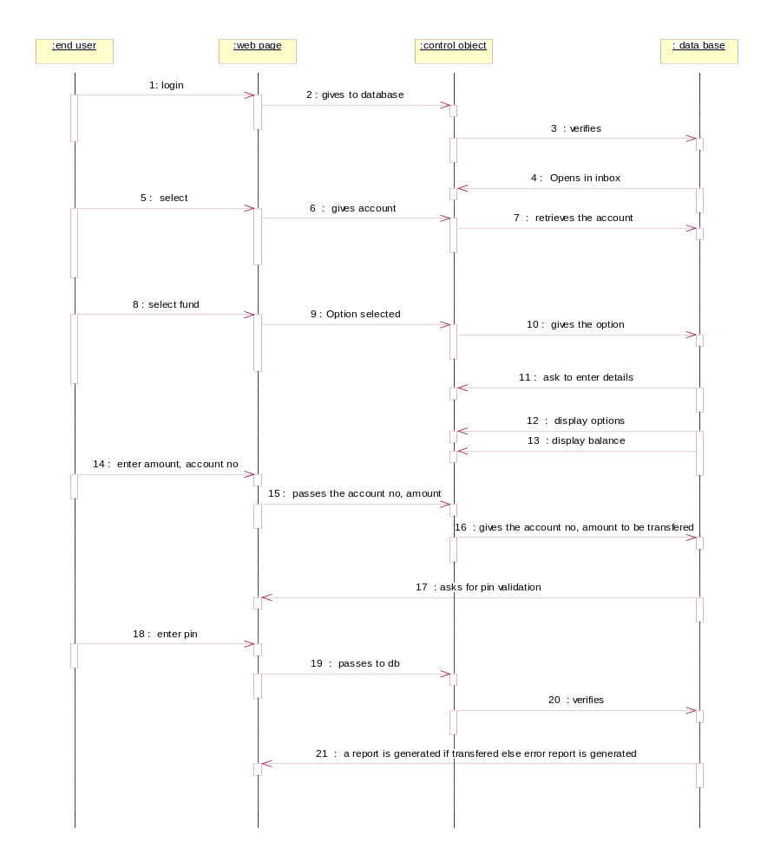

Fig 2.2.2: sequence diagram for Internet banking System

2.2.3 COLLABORATION DIAGRAM

A collaboration diagram is an interaction diagram that shows the order of messages that implement an operation or a transaction. It represents collaboration diagram objects. It is nothing but a set of objects related in a particular content and interaction. In this diagram numbering the message indicates the sequence.
Collaboration diagram show exactly the same information the sequence diagram shows. But the purpose of collaboration diagrams is different. The collaboration diagram shows the objects and actor interaction without reference to time.
Quality assurance engineers and system architects view at these diagrams to see the distribution of processing between objects. For example, in a collaboration diagram several objects communicate with central object. A system architect then concludes that the systems is too dependent on central object and redesign the objects to distribute the processing more evenly.

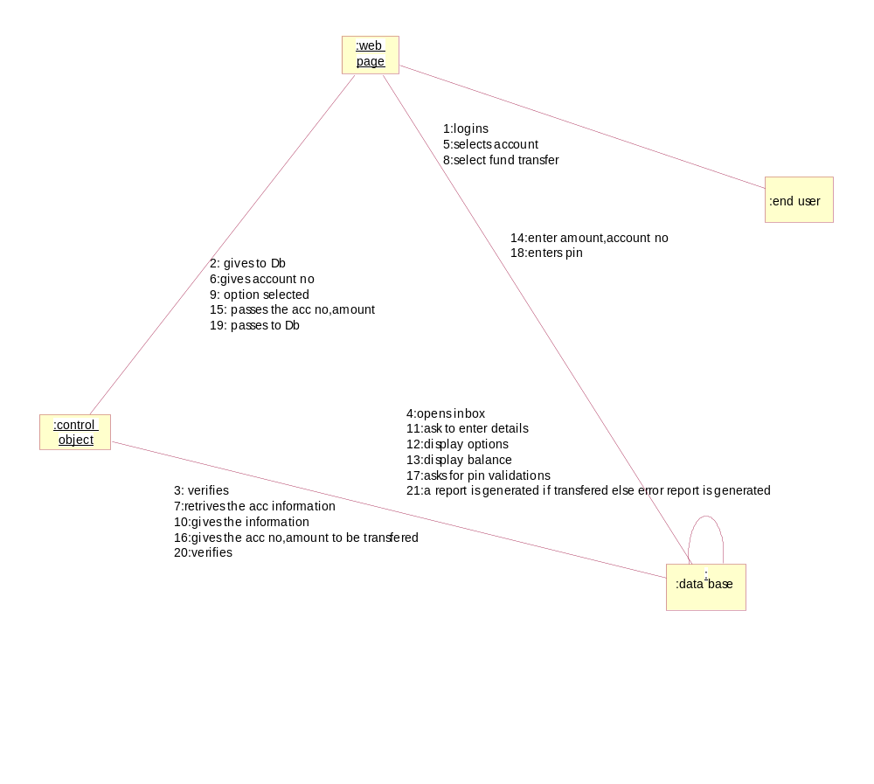

Fig 2.2.3: collaboration diagram for Internet Banking System

2.2.4 ACTIVITY DIAGRAM
An Activity diagram shows the flow from activity to activity. An activity is a going non-atomic execution within a state machine. An activity results in some action, results in a change of state or return of a value. Action encompasses calling operation, sending a signal, creating or destroying objects, or a pure computation such as evaluating some expression.
It is used to model an entire business process. It provides a flow of program. It is used to show internal state of a object but external events may appear in them. It decides the sequence of activities, with support for both conditional and parallel behavior.
Activity diagram is similar to a Flowchart. An UML Activity diagram shows what actions takes place during a process or an operation. We might use an activity diagram to explore a business process or a soft process what happens in an individual use case or across several use cases. An activity is made up of series of actions. An activity is a process and each step in a process is an action in UML .Each action is represented by a rounded rectangle. Here the arrows represent “control flows”. The arrows show the direction of flow which step in the process comes next.

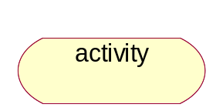

ACTIVITY DESCRIPTION
The arrows coming out of the decision node has [Guard conditions] if true one path or else other. The end point shows where the process ends.
Activity diagram can be drawn for a each use case or else several use cases. An executable atomic computation is called action state, which cannot be decomposed. They rendered as lozenge shape. Activity state is non atomic, decomposable and take some duration to execute.
Branch: It has a single incoming transition and several guarded outgoing transitions. Only one of the outgoing transition can be taken, so the guards should be mutually exclusive.
Merge: It has multiple input transitions and a single output. A merge marks the end of conditional behaviour started by a branch.
Forks and Joins indicate parallel behavior.
Fork: It has one incoming transitions. When the incoming transitions triggered, all of the outgoing transitions are taken in parallel.
Join: In this, a outgoing transition is taken only when all the states on the incoming transitions have complete their activities.

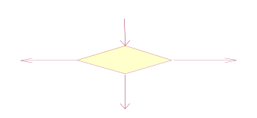 | Branch
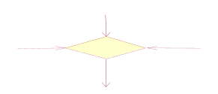 | Merge
 | Fork
 | Join

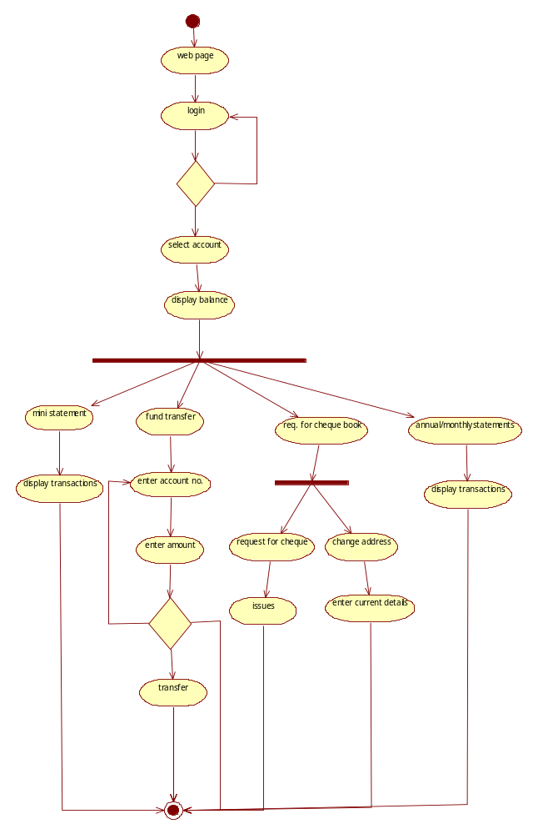

Fig 2.2.4: activity diagram for INTERNET BANKING
3. SYSTEM DESIGN

3.1 CLASS DIAGRAM
A class diagram shows a set of classes, interfaces, and collaborations and their relationships. The diagrams are most common diagrams founding modeling object-oriented systems.
Class diagram represents class name, attribute and method. It shares the same attributes, operations, relations and semantics.
Class – it is description of a set of objects.
Attribute – it represents the property of a class.
Methods – performing operations on date.
A class is something that provides blueprint for an object. In other words class defines what information and object can hold and the operations that can be performed on the attributes of the objects of class.
Class diagram representation
Class name
attributes
operations

A class is a set of objects that share a common structure and common behavior (the same attributes, operations, relationships and semantics). A class is an abstraction of real-world items. When these items exist in the real world, they are instances of the class and are referred to as objects.

Relationship among classes

Relationship provides a pathway for communication between objects. The four kinds of Relationships are Dependency (use), Generalization (Inheritance, is-a), Aggregation (whole-part) and Association (defined relation).

- Dependency: Dependency describes a using relationship. Therefore change in specification of one class may affect another class that uses it.
Class A
Class B

- Generalization: Generalization is described as an “is-a-kind-of” relationship. Classes are ordered within a hierarchy; a super class in an abstraction of its subclass
- .Specialization: It allows the capture of the specific features of a set of objects that have not been distinguished by the classes already defined. It is an extending technique, of a subclass with new characteristics.
- Association: This represents the structured relationship between classes. They are bi- directional. They can be traversed in both directions, with different directions. The direction implied by the name is the forward direction; the opposite direction is the inverse direction. A role denotes purpose capacity where in one class is associated with another class.

Role A
Class A
Class B
Role B
- Cardinality: It specifies how many instances of one class may relate to a single instance of an association class. “How many” is called the Multiplicity of an association.

Symbol | Meaning
1  0..1  M..N  *  0..*  1..* | One and only one  Zero or one  Numerically specified  From zero to any positive integer  From zero to any positive integer  From one to any positive integer

- Aggregation: It is a form of association. It indicates a whole-part relationship. The whole is responsible for the parts. Operations on the whole propagate to parts.
College
Department

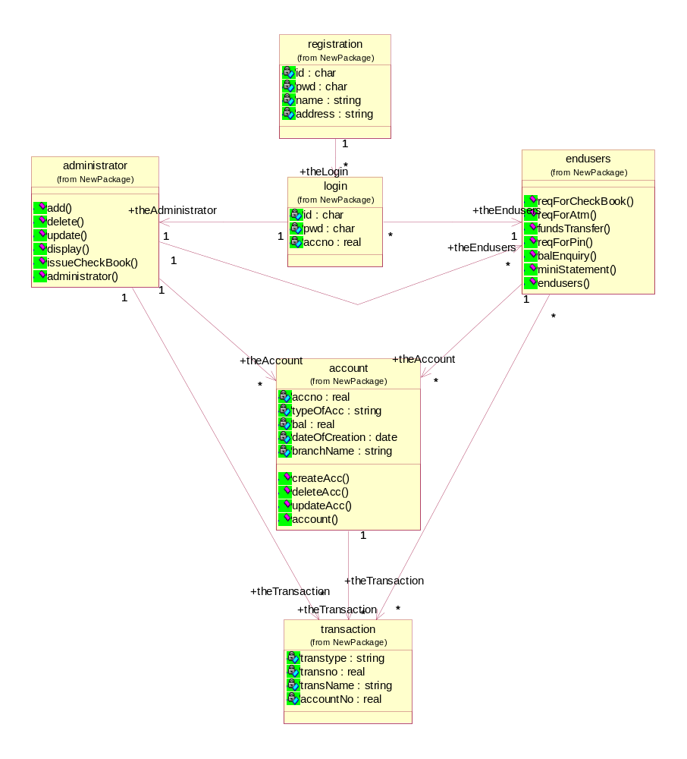

Fig 3.1: class diagram for internet banking

3.2 STATE CHART DIAGRAM

A state diagram shows a state machine, consisting of states, transitions, events and activities. A state diagrams shows the dynamic view of an object. They are especially important in modeling the behavior of an interface, class, or collaboration and emphasize the event-ordered behavior of an object, which is especially useful in modeling reactive systems.

State transition diagram provide a way to model the various states in which the class diagrams show a static picture of the classes.
- State chart diagram is used to model the various states in which an object can exist.
- While a class diagram shows the static picture of classes and their relationships
- A state chart diagram shows the behavior of an object
- For example a bank account can exist in several different states
- It can be opened, closed or withdrawn.
- An account may behave differently when it is in each of these states.

STATE
State is a condition satisfied by the attributes of an object.
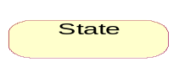

TRANSISTION
A state transition indicates that an object in the source state will perform certain specified actions and enter the destination state when a specified event occurs or when certain conditions are satisfied. A state transition is a relationship between two states, two activities, or between an activity and a state.
You can show one or more state transitions from a state as long as each transition is unique. Transitions originating from a state cannot have the same event, unless there are conditions on the event.
The icon for a state transition is a line with an arrowhead pointing toward the destination state or activity.
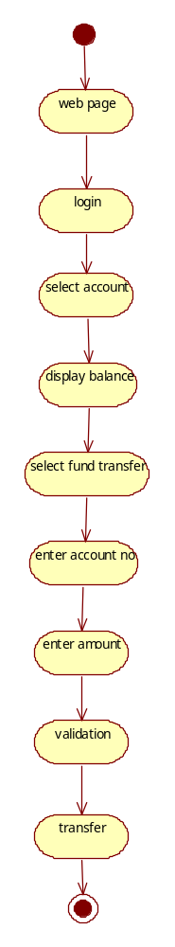
Fig 3.2: state chart diagram for Internet Banking

3.3 COMPONENT DIAGRAM
Component diagram show a physical view of your model. A component diagram shows you the components in your system and the relationships between them. These high level physical components may or may not be equivalent to the many smaller components you use in creation of application.
Component diagrams provide a physical view of the current model. A component diagram shows the organizations and dependencies among software components, including source code components, binary code components, and executable components. These diagrams also show the externally-visible behavior of the components by displaying the interfaces of the components. Calling dependencies among components are shown as dependency relationships between components and interfaces on other components. Note that the interfaces actually belong to the logical view, but they can occur both in class diagrams and in component diagrams.
Component diagrams contain:
·Component packages
·Components
·Interfaces
.Dependency relationships

COMPONENT PACKAGE
Definition: Component packages represent clusters of logically related components, or major pieces of your system. Component packages parallel the role played by logical packages for class diagrams. They allow you to partition the physical model of the system.
Naming: Typically, a component package name is the name of a file system directory.
Relationships: A component package can have dependencies with other component packages, components, and interfaces.

Graphical Depiction: The component package is a folder shaped icon:

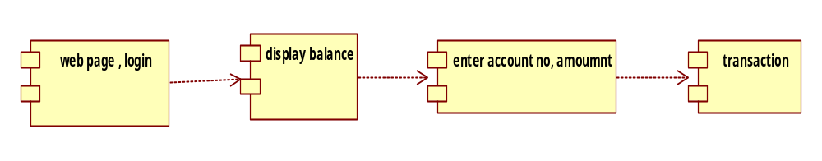

Fig 3.3: component diagram for Internet Banking

3.4 DEPLOYMENT DIAGRAM
Deployment shows the physical layout of the network and where the various components will reside. It represents a graph of nodes connected by communication association. Nodes contain component instances, which means that the component live or runs at those nodes.
Deployment diagram commonly contains:
  - Nodes
  - Dependency and association in one of 3 ways
- To model Embedded System.
- To model Client\server System
- To model fully distributed system
Node: Node is another name for an object in the model hierarchy. Nodes are displayed in the browser window. Each node has properties, which are displayed in the property view window when the node is selected in the browser. Examples of nodes are classes, use cases, objects, operations, components, and diagrams.
Processor: A processor is a hardware component capable of executing programs.
Naming: Each processor must have a name. There are no constraints on the processor name because processors denote hardware rather than software entities.

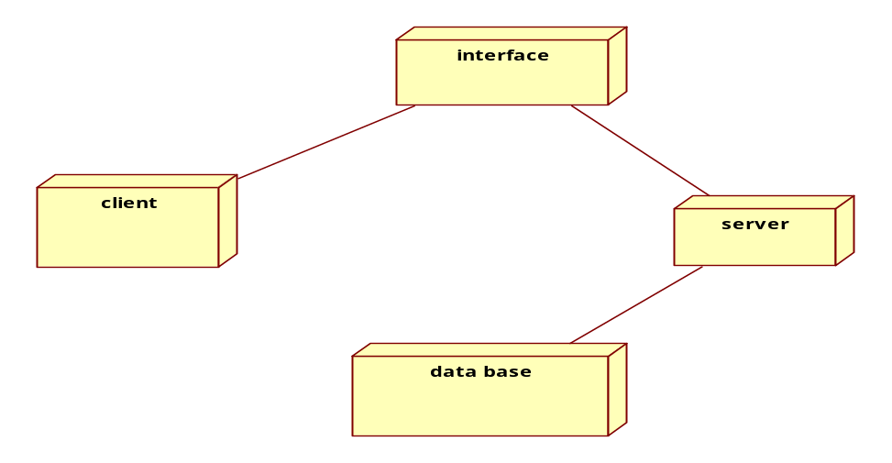
Fig 3.4: deployment diagram for Internet Banking

4. ACCESS LAYER DESIGN(CODING)

Table for account class
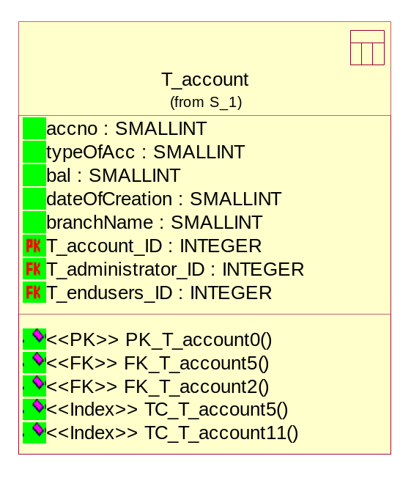
//Source file: D:\\IB\\account.java
public class account
{
private real acno;
private string typeofac;
private real bal;
private date dateOfCreation;
private string branchName;
public transaction theTransaction[];
/**
* @roseuid 4D79CBA902AF
*/
public account()
{
}
/**
* @roseuid 4D79C89B009C
*/
public void createAcc()
{
}
/**
* @roseuid 4D79C8A90232
*/
public void deleteAcc()
{
}
/**
* @roseuid 4D79C8BB032C
*/
public void updateAcc()
{
}
}

Table for administrator calss
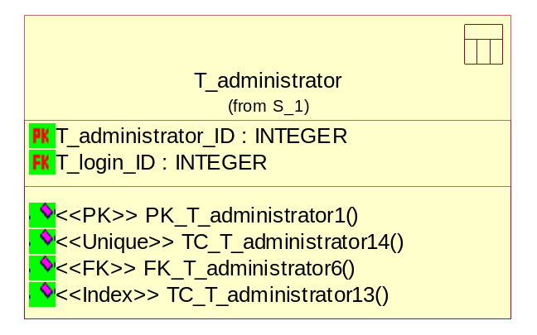
//Source file: D:\\IB\\administrator.java
public class administrator
{
public endusers theEndusers[];
public account theAccount[];
public transaction theTransaction[];
/**
* @roseuid 4D79CB6A003E
*/
public administrator()
{
}
/**
* @roseuid 4D79C8E2033C
*/
public void add()
{
}
/**
* @roseuid 4D79C8E70157
*/
public void delete()
{
}
/**
* @roseuid 4D79C8EB02BF
*/
public void update()
{
}
/**
* @roseuid 4D79C8F10232
*/
public void display()
{
}
/**
* @roseuid 4D79C8FB0242
*/
public void issuecheckbook()
{
}
}
Table for endusers
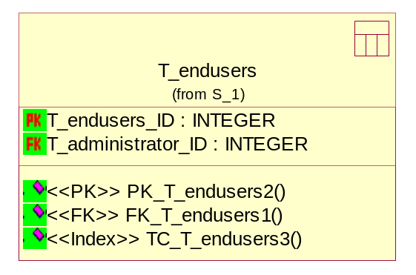
//Source file: D:\\IB\\endusers.java
public class endusers
{
public account theAccount[];
public transaction theTransaction[];
/**
* @roseuid 4D79CB7901A5
*/
public endusers()
{
}
/**
* @roseuid 4D79C9DD02BF
*/
public void reqforcheckbook()
{
}
/**
* @roseuid 4D79C9E502EE
*/
public void reqForAtm()
{
}
/**
* @roseuid 4D79C9F00280
*/
public void fundsTransfer()
{
}
/**
* @roseuid 4D79C9FE008C
*/
public void reqForPin()
{
}
/**
* @roseuid 4D79CA0F00BB
*/
public void balEnquiry()
{
}
/**
* @roseuid 4D79CA1A02AF
*/
public void miniStmt()
{ }
}
Table for login class
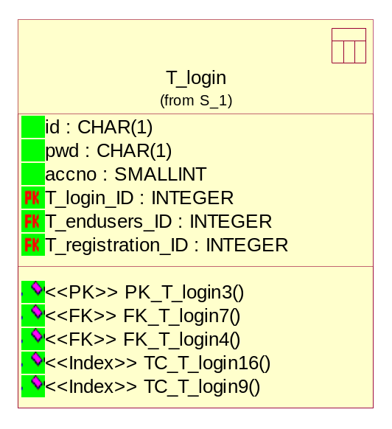
//Source file: D:\\IB\\login.java
public class login
{
private char id;
private char pwd;
private real accno;
public administrator theAdministrator;
public endusers theEndusers;
/**
* @roseuid 4D79CB71037A
*/
public login()
{
}
}

Table for registration class
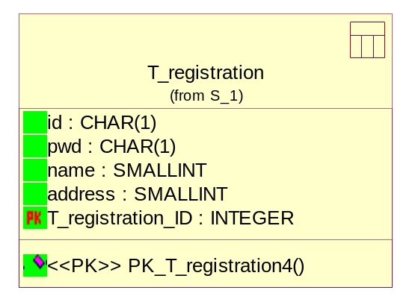

//Source file: D:\\IB\\registration.java
public class registration
{
private char id;
private char pwd;
private string name;
private string address;
public login theLogin[];

/**
* @roseuid 4D79CB630000
*/
public registration()
{
}
}

Table for transaction class
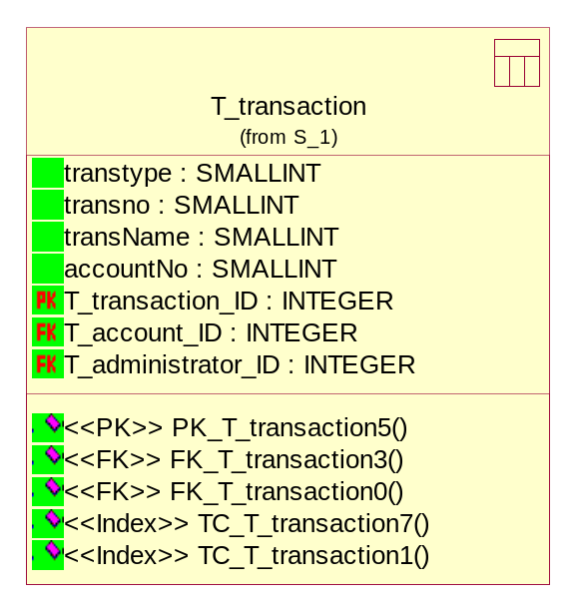
//Source file: D:\\IB\\transaction.java
public class transaction
{
private string transtype;
private real transno;
private string transname;
private real accno;
/**
* @roseuid 4D79CBE7029F
*/
public transaction()
{
}
}

5. CONCLUSION
The advantage is that this can be done anywhere as long as one has internet access, one can practice Internet Banking. One can request for cheque books and ATM cards without going to bank and wasting much time. This makes the user to access his/ her account transactions for 24 hours and 365 days.

6. BIBILIOGRAPHY
- Professional Java Server Programming
- Object Oriented Development-Ali Bahrami
- Fundamental of Data Base systems-Elmasri&Navathe
- Object Oriented Software Engineering – Bernd Bruegge
- Software Engineering – Lan Sommerville

